*Searching Inventory for parts*

Before ordering parts for customers or inventory it is important to first check current inventory levels. Click Inventory on the toolbar to open the inventory list

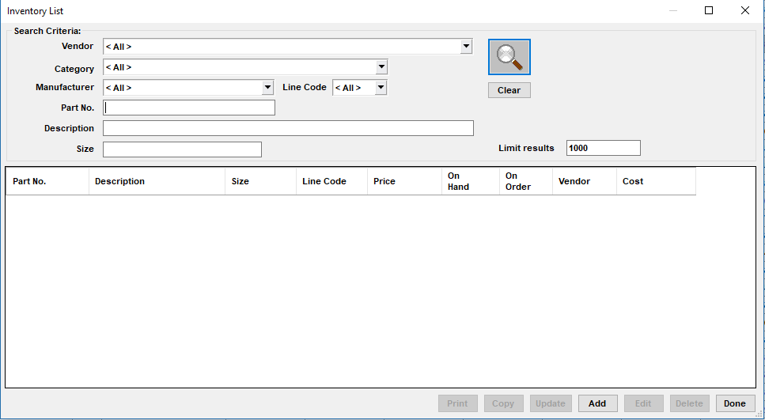

Here you can look up parts, add parts to inventory and edit current inventory parts.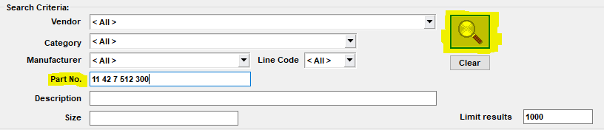

Leaving the vendor category and manufacturer codes as ALL is recommended. Part numbers must be entered in a specific way (ex: 12 12 1 123 123) however you can also just enter the first 4 numbers to bring up any parts starting with those numbers.

After typing in a part number hit enter or the search button

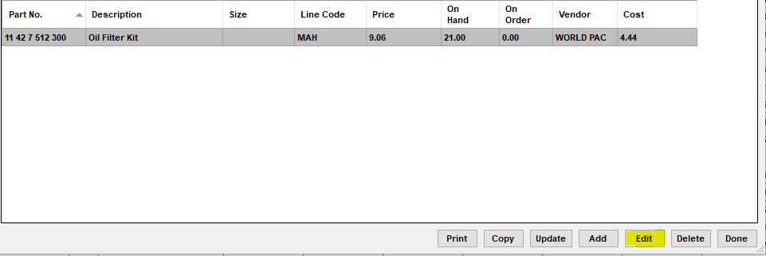

If a part is in inventory it will show up in the list, here you can double click on the part number or hit edit down at the bottom. This will bring up all the information for the part. There is a couple things you will want to look out for

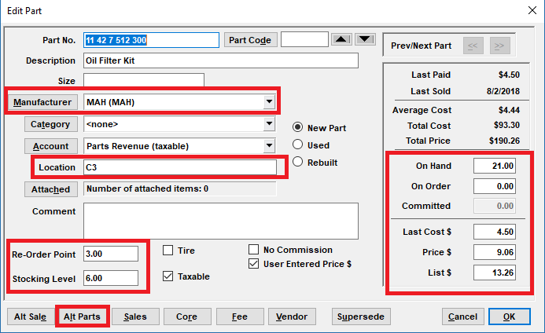

Manufacturer Code – the brand of the part(s) in stock

Location – where the part is being stored, all shelves walls and bins are labeled

On Hand - quantity currently in stock, this must be accurate

On Order – If parts have been ordered it will reflect here

Re-Order Point – when on hand quantity is the same or less than the reorder point that means more are needed for stock

Stocking Level – How many of a part to keep in stock

If you want to check inventory for a part on a customer repair order you can also do it through the RO

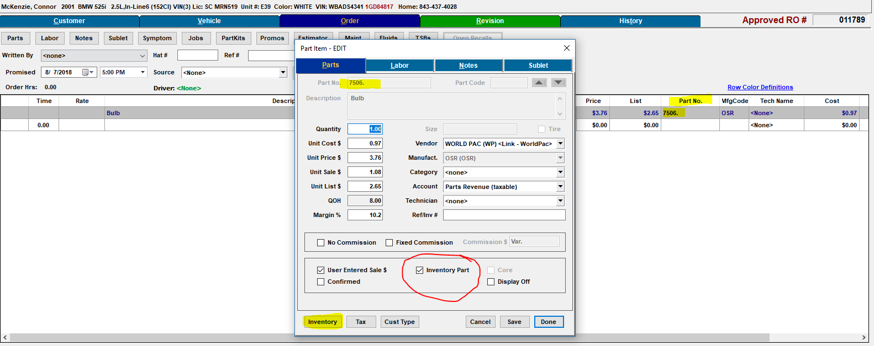

Some parts will be checked as inventory parts, others will not. Check inventory in any case

IMPORTANT: after clicking inventory in the window above and searching for a part, make sure you click edit instead of double clicking otherwise it will transfer the part back to the RO click cancel if that happens

------------------------------------------------------------------------------------------------------------------------------------------

*Adding parts to inventory*

Adding parts to inventory is a simple process, it should be done only through the inventory list, not through repair orders.

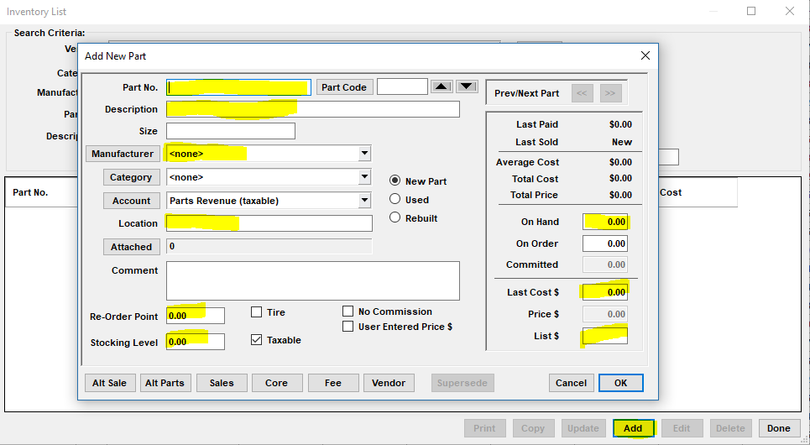

Make sure everything highlighted is filled out and save the part number by clicking [OK]